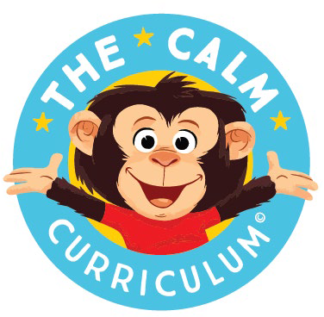
Certificate of Attendance
The CALM Connection Parent Group
[add dates here]

[add name here]
Has attended 12 hours of The CALM Connection Parent Group. Topics included: Connect and Reflect, Emotional Awareness, I CARE Response, Executive Function, Yes Brain, Growth Mindset & Motivation.

[your name] [Co-facilitator name]
CALM Connection Facilitator CALM Connection Facilitator
[your agency’s name}

www.connectwithcalm.ca

